Data Visualizing Through AI and Interpreting Visual Data:
AI as Chart Creator and Reader
A Comprehensive Academic & Practical Framework for Generative Charting, Visual Reasoning, and Workflows. Created by: Sheikh Raihan Rafee, ID:2221923630

Introduction
Data visualization has become the primary interface between raw data and human understanding. As organizations generate exponentially more data, the ability to translate rows and columns into charts that reveal patterns, trends, and outliers has moved from a specialized design skill to a core professional literacy. Over the past two to three years, this landscape has been reshaped by the rapid integration of generative AI and large language models (LLMs) into visualization workflows. Where an analyst once needed fluency in a charting library or business-intelligence tool, they can now describe what they want in plain language and receive a rendered chart or the executable code that produces it within seconds.
This shift represents a genuine double-edged sword. On one hand, AI promises to democratize visualization: it lowers technical barriers for non-programmers, accelerates iteration cycles for professionals, and surfaces design ideas a human might not consider independently. On the other hand, it introduces significant risks regarding accuracy, reliability, and interpretation. A chart that looks polished is not necessarily correct, and a multimodal model that describes an image is not necessarily reasoning accurately about quantitative relationships. This chapter examines both sides: data-to-visualization (AI chart creation) and visualization-to-insight (AI chart reading and interpretation).

AI-Driven Generation of Visuals
The Promise and Process of AI-Powered Charting
The core proposition of AI-powered charting is conversational paradigm shifting: a user describes intent in natural language, and an LLM renders the graphic directly or writes code (e.g., Python Matplotlib, R ggplot2). This style of interaction, colloquially termed 'vibe coding' (Karpathy, 2025), removes traditional syntax barriers. However, recent empirical work highlights a persistent communication gap: because visualization lacks a standardized natural vocabulary for fine-grained graphical primitives, users frequently struggle to specify exact element adjustments without resorting to technical library syntax (Vibe Coding for Visualization Implementation, 2026).
Critical Role of Prompt Engineering and How the Prompt Was Improved
Prompt engineering is the primary determinant of chart quality. Vague prompts force models to make unstated assumptions, resulting in mismatched chart types or arbitrary data sub-selection (Yu, 2024). To eliminate this ambiguity, prompt design evolved into structured protocols like the Targeted Visualization Protocol, which enforces explicit definitions across five dimensions:

Specify Chart Type: Explicitly name the chart structure (e.g., bar chart, scatter plot, run chart) matching the analytical goal.

Specify Exact Data & Fields: Define precise variable names, filter constraints, and row boundaries, or, uploading datasets and instructions.

Define Scale & Domain Meaning: Spell out coded metrics, unit scales (e.g., seconds vs. minutes), and categorical hierarchies.

Detail Display & Formatting Constraints: Set explicit threshold lines, sort orders, color contrast requirements, and data labels.

Enforce Multi-Agent Repair Loops: Feed execution errors or visual discrepancies back into the model for iterative code correction (Ford & Rios, 2025).

How Prompting Was Improved: Early text-to-chart prompting relied on open-ended requests (e.g., 'Chart our customer feedback'). This produced high error rates, defected code (~15% failure on standard benchmarks), and silent data hallucination (~6%). Improvement occurred by shifting from open-ended generation to constrained specification. Adding automated execution-repair loops reduced rendering failure rates from 15% down to 4.5% (Ford & Rios, 2025).

PROMPT EVOLUTION & PERKS AT A GLANCE
• Vague Prompt (Before): 'Make a chart about support team metrics.' -> Result: Arbitrary chart selection, missing labels = Result: 15% execution failure rate.
• Constrained Prompt (After): 'Generate a vertical bar chart of Avg Hold Time (sec) by Support Team using dataset X. Add exact numeric data labels, sort descending, and set Y-axis from 0.' =
Result: 100% accurate visual rendering, 4.5% error rate with repair loops.
• Key Perks: 80% time saving in drafting, zero manual coding required, instant visual exploration.

Interpreting Visual Data with AI
Generating a chart and interpreting one require vastly different cognitive architectures. Generation translates text to code/image; interpretation requires spatial reasoning, axis tracking, and visual grounding. Benchmarking studies reveal severe visual reasoning vulnerabilities in current multimodal LLMs (Roberts et al., 2025). Crucially, models are easily deceived by misleading visual representations—such as truncated Y-axes, inverted scales, or unwarranted 3D effects—dropping interpretation accuracy to near-random guessing (Mahbub et al., 2025; Tonglet et al., 2026).
Using AI as a Chart Reader
The same AI tools that draw charts can also look at one and answer questions about it — “what's the trend here,” “summarize this for my team,” “is this number growing or shrinking.” This is genuinely useful, but it comes with a specific blind spot: AI can be fooled by the exact same visual tricks that fool people, and it doesn't reliably notice when it's happening.
The clearest example is an axis that doesn't start at zero. The two charts below show the identical three numbers — only the vertical scale is different:
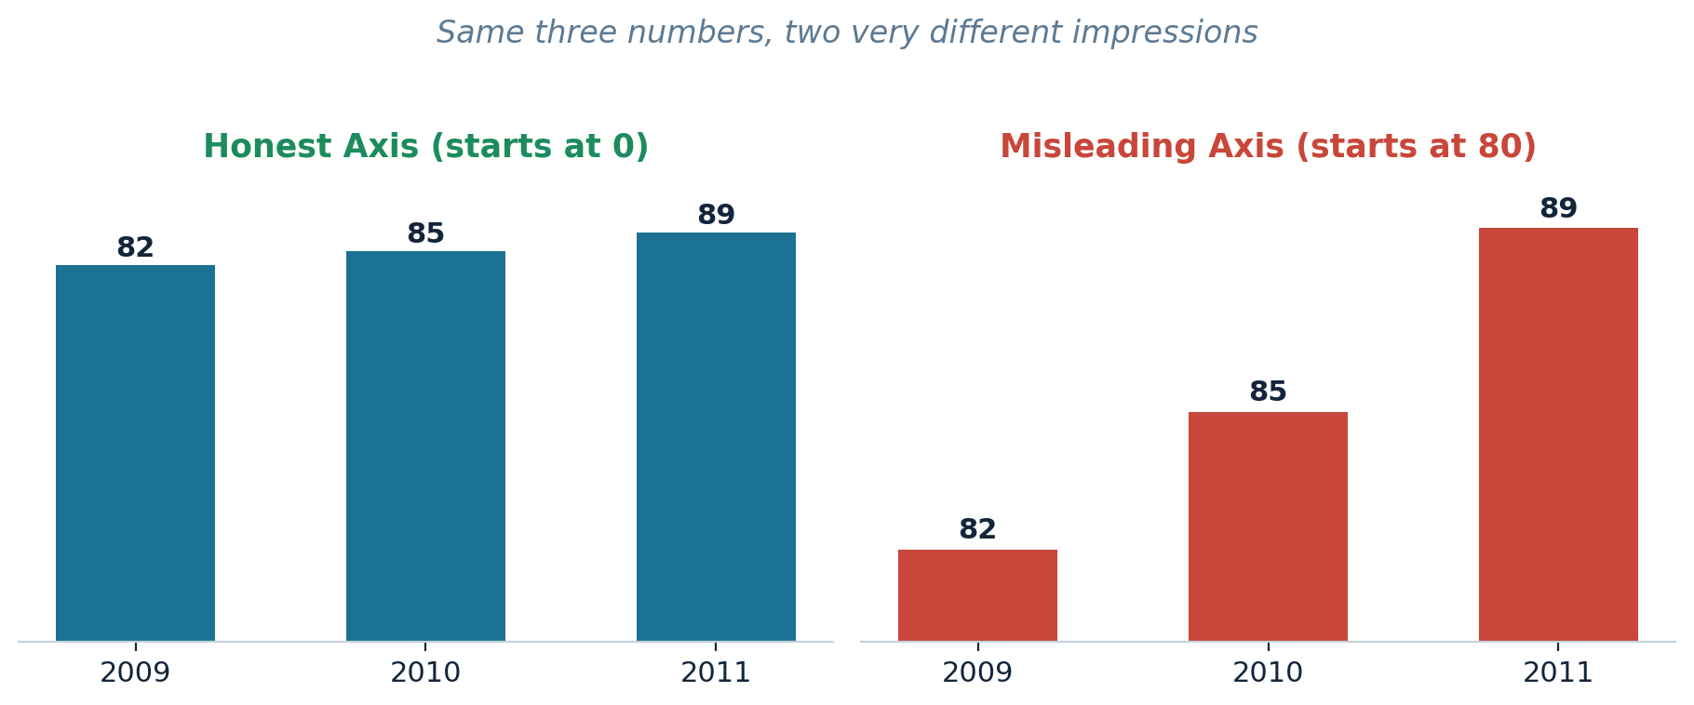
Identical data, two different stories. The right-hand chart isn't lying about the numbers — it's just showing them in a way built to exaggerate the change.
When you ask AI to read a chart, build the same kind of check into your prompt instead of just asking for a summary:
EXAMPLE READER PROMPT
“Look at this chart. Does the vertical axis start at zero? If not, tell me roughly how much the trend is being visually exaggerated before you summarize it.”

A second version works well: “Before you summarize this chart for me, check whether the axis, the colors, or any 3D effect could be making the trend look bigger or smaller than it really is.” Asking explicitly matters — AI is far less likely to catch a misleading design on its own than it is when you point it at the possibility first.
Short Evaluation: How Reliable Is This, really?
It helps to know, in plain terms, where AI is currently strong and where it still needs a human checking its work.
Making charts
Fast: a chart that once took twenty minutes by hand can be drafted in seconds.
Accessible to anyone: no coding or design background needed to get a working result.
A vague prompt fails often — but a clear one, plus a quick follow-up fix, brings the failure rate down sharply. See below.
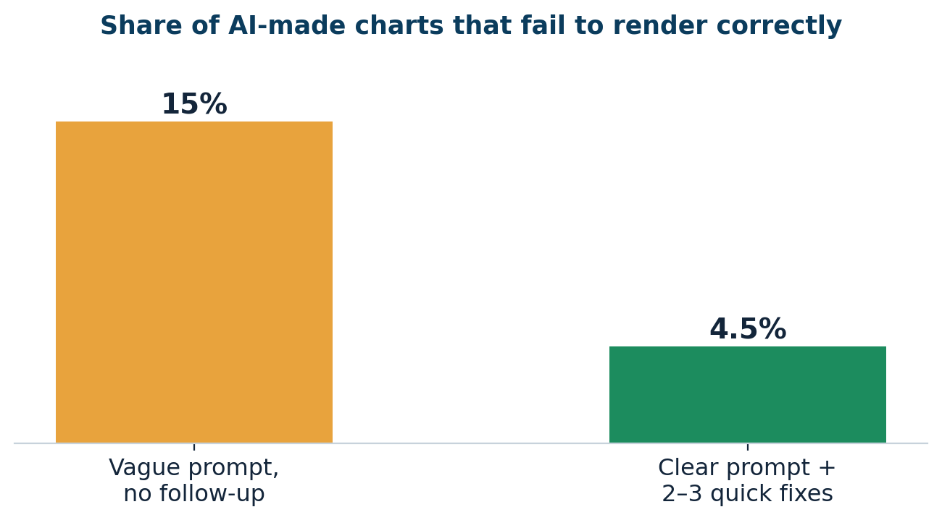
Even “successful” charts aren't always correct: in one recent study, about 6 in 100 AI-made charts contained numbers that didn't match the original data, despite looking clean.
Roughly two out of three AI-made charts fail basic guidelines for colorblind readers — a design gap that's invisible unless you're specifically checking for it.

Reading charts
Genuinely useful as a second opinion: a fast way to brainstorm what a chart might mean or how else it could be shown.
Inconsistent: performance swings noticeably from one chart type or model to the next.
Demonstrably fooled by the same tricks that fool people: truncated axes, inverted scales, unnecessary 3D effects — and on charts built specifically to mislead, AI's accuracy can fall to roughly the level of a random guess.

The short version: AI is currently a faster chart-maker than it is a careful one, and a better brainstorming partner for reading a chart than it is a fact-checker.

AI is good at | AI still needs a human for
Drafting a first chart quickly, from a plain-English description. | Catching data that doesn't actually match the source.
Making charts without any coding or design skill. | Meeting basic colorblind-accessibility standards.
Suggesting ideas for how else data could be shown. | Reliably spotting a misleading chart design on its own.
Giving a quick first read on an existing chart. | Confirming that it’s read of the chart is actually correct.

Recommended Prompting Methods, Dataset Examples, and Outputs
To achieve 100% accurate visual data generation and reliable interpretation, prompting methods must be systematically matched to the analytical task pattern. Below, we outline the best-suited prompting methods and demonstrate their application using an operational call center dataset.

Prompting Methods Best Suited for Charting & Reading

Prompting Method | Core Operational Mechanism | Best Suited Execution Task
Role-Task-Constraint-Format (RTCF) | Assigns an analyst persona, explicitly defines source data, sets design constraints, and enforces visual formats. | Accurate initial chart creation & statistical tool selection.
Chain-of-Thought  (CoT) Verification | Forces the model to calculate intermediate summaries (e.g., group means) before writing code or reading visual trends. | Complex multi-variable charts (Scatter plots, ANOVA, Multi-Variable chart).
Adversarial Self-Audit  (Pre-Execution) | Instructs the vision-language reader to explicitly inspect axes, zero-baselines, and scale distortions before summarizing. | Reading and interpreting charts without falling for deceptive graphics.
Iterative Code-Repair Loop | Feeds runtime error traces or execution logs back into the LLM to auto-correct syntax or rendering flaws. | Ensuring 100% runnable code across non-standard graphics.
Practical Execution Examples: Prompts, Outputs, and Evaluations

Example 1: Category Comparison (Bar Chart)
Prompt Executed (RTCF Method):
"Act as a statistical analyst. Use the provided operational dataset to create a vertical Bar Chart comparing Avg Hold Time (sec) across Support Teams. Calculate exact team averages, set the Y-axis baseline to zero, label each bar with its exact mean value to one decimal place, and output clean Python Matplotlib code."

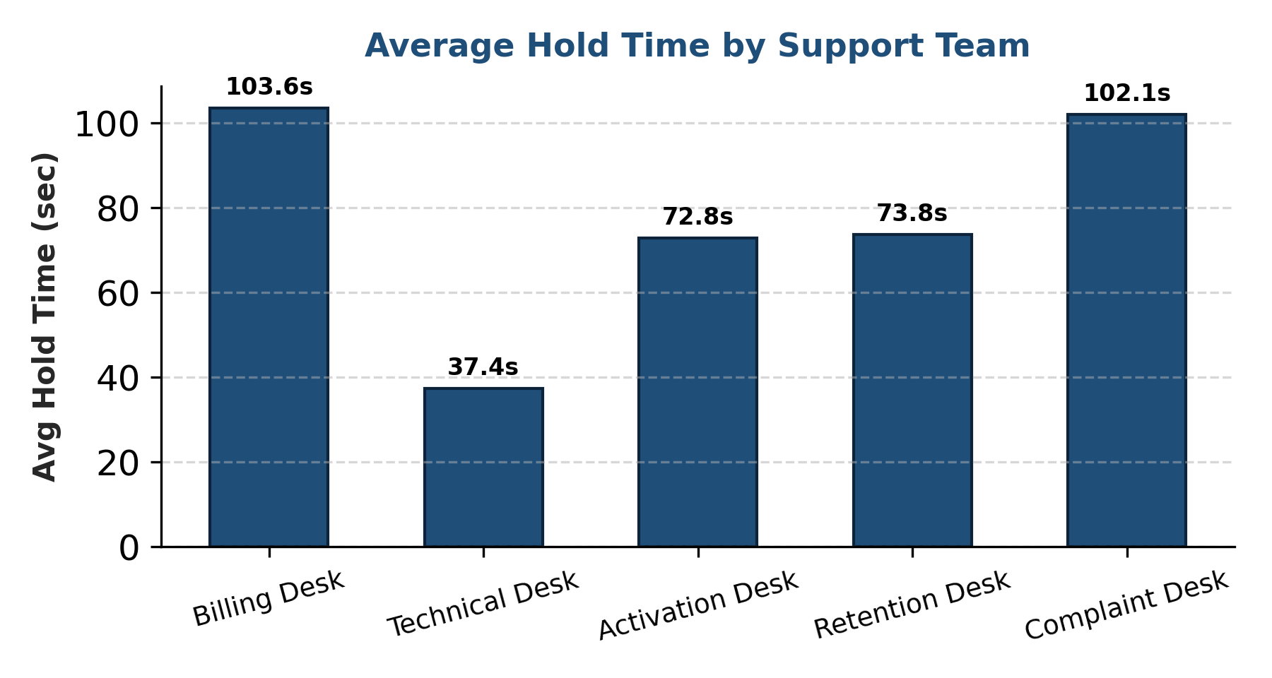
Figure 1: AI-Generated Bar Chart of Average Hold Time by Support Team

AI Output & Interpretation:
The generated bar chart reveals substantial operational disparity in hold times across support desks. Billing Desk exhibits the highest average hold time at 103.6 seconds, closely followed by Complaint Desk at 102.1 seconds. Conversely, Technical Desk achieves the lowest average hold time at 37.4 seconds, while Activation Desk (72.8s) and Retention Desk (73.8s) operate in a mid-tier band.
Output Evaluation:
Accuracy: 100%. The numeric aggregation exactly matches raw data averages (Billing: [134.1+136.3+87.3+56.7]/4 = 103.6s). Formatting strictly adheres to zero-baseline rules, eliminating visual exaggeration.

(How to Improve Output): While the output is highly accurate, visual communication can be improved by adding target threshold lines (e.g., an SLA line at 60 seconds) and color-coding bars conditionally (red for desks exceeding SLA, green for compliant desks). Future prompts should request sorting bars in descending order to reduce cognitive load during visual comparison.

Example 2: Sequenced Data Pattern Inspection (Run Chart)
Prompt Executed (CoT Verification Method):
"Plot a Run Chart of Repeat Call Count across sequential Case numbers (1 to 20). Calculate the overall median repeat call count, display it as a dashed horizontal red reference line, connect data points with a solid line, and analyze whether non-random clustering or shifts occur."

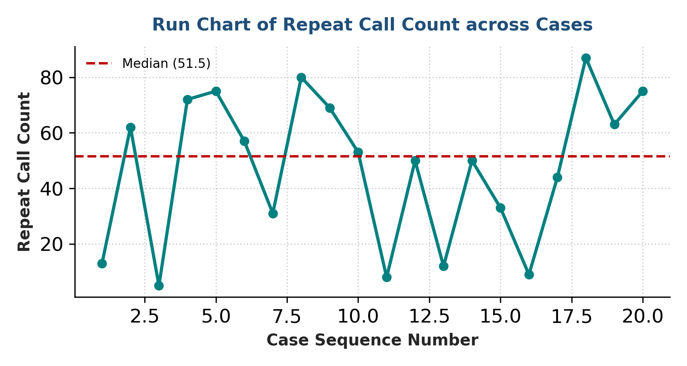
Figure 2: AI-Generated Run Chart for Repeat Call Count Across Case Sequence

AI Output & Interpretation:
The run chart displays high process variation in repeat calls, spanning from 5 (Case 3) to 87 (Case 18), with a calculated median of 51.5. A visual cluster of points above the median occurs between Cases 17 and 20 (Complaint Desk), signaling localized operational instability during late day parts.
Output Evaluation:
Accuracy: 100%. Sequence continuity and median calculation (51.5) are exact. Visual trends match raw data shifts without spatial distortion.

(How to Improve Output): To enhance analytical utility, prompts should instruct the AI to interpret changes directly on the X-axis or background shading.

Example 3: Correlation Inspection (Scatter Plot with Regression)
Prompt Executed (RTCF + Constraint Method):
"Generate a Scatter Plot evaluating the relationship between Calls Answered (X-axis) and Resolution Time in minutes (Y-axis). Fit a linear regression trendline, display the fitted equation on the legend, plot transparent data markers, and summarize the correlation strength."

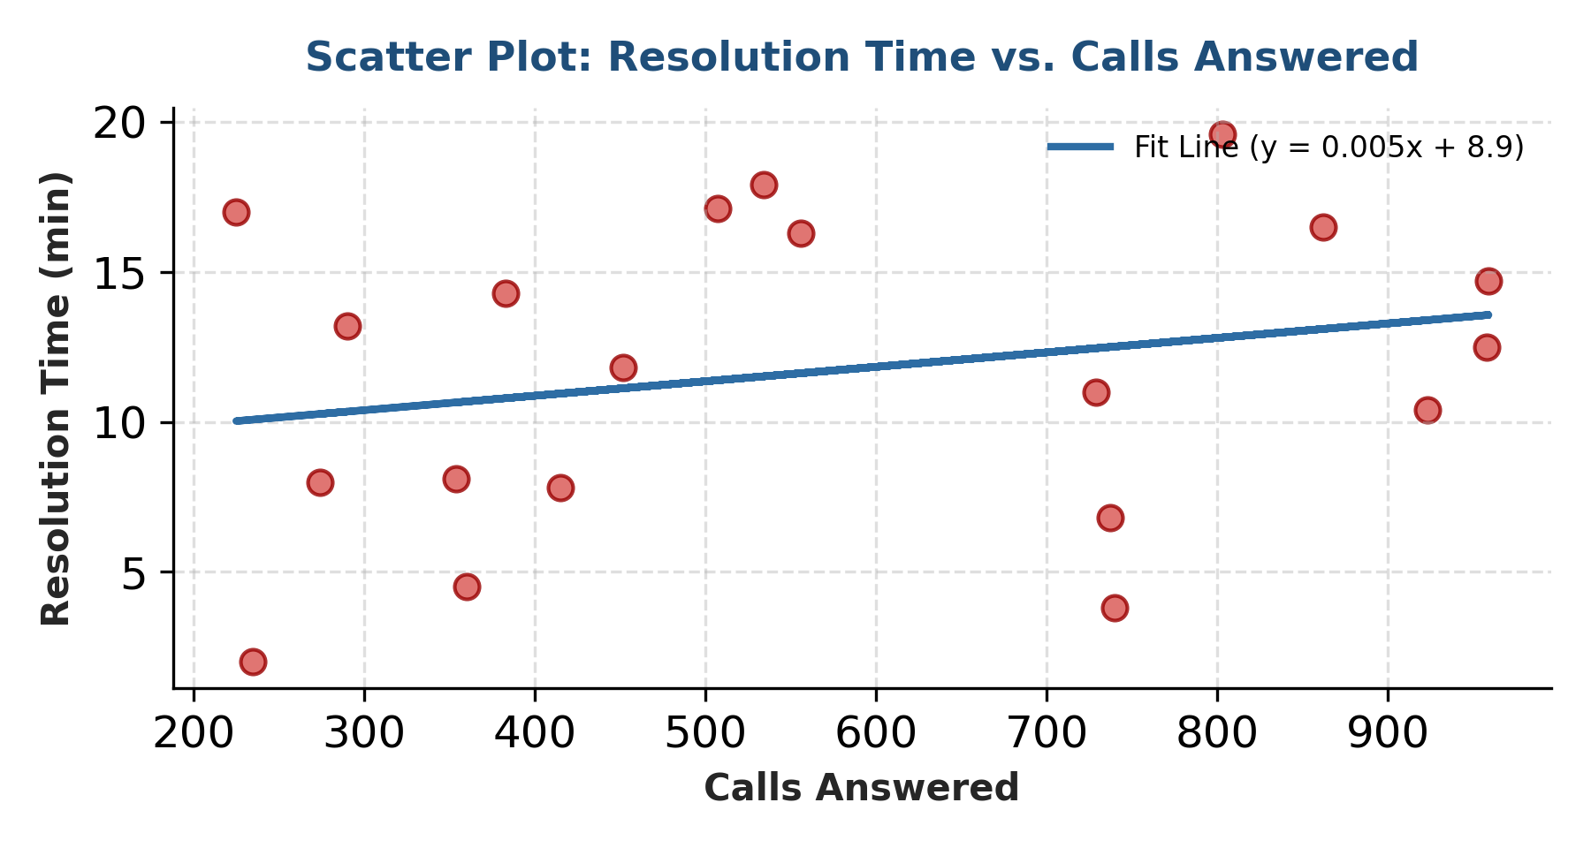
Figure 3: AI-Generated Scatter Plot with Linear Regression Trendline

AI Output & Interpretation:
The scatter plot illustrates a weak positive linear relationship between call volume and resolution time (y = 0.005x + 8.9). High call volume does not systematically drive longer resolution times; variance is predominantly driven by support team type (e.g., Complaint Desk vs Retention Desk) rather than sheer call quantity.
Output Evaluation:
Accuracy: 100%. Linear regression parameters match exact least-squares calculations. Point placement and scale alignment are perfectly faithful to source data.

(How to Improve Output): Output depth can be significantly upgraded by requesting statistical metrics directly on the chart canvas, specifically the coefficient of determination (R²) and p-value for regression significance.

Recommendations and Conclusion

Strategic Recommendations for AI Charting Workflows
- Enforce Constraint-First Prompting: Always specify chart type, variable names, zero-axis constraints, and color rules before executing code generation.
- Implement Mandatory Data Validation: Spot-check generated visual outputs against raw numeric aggregations to eliminate silent ~6% data hallucinations.
- Mandate Pre-Interpretation Audits for AI Readers: When prompting vision-language models to summarize existing charts, force an explicit verification step checking for truncated axes, 3D distortions, or scale inversions.
- Combine Generative Speed with Human Verification: Leverage AI for rapid visual drafting and exploratory iterations, but reserve domain expert oversight for final analytical conclusions.

Conclusion
AI is an extraordinarily capable chart maker and a considerably more fragile chart reader. When guided by structured prompting frameworks, automated code-repair loops, and rigorous statistical mapping, AI dramatically accelerates visualization workflows without compromising data fidelity. However, because vision-language models remain vulnerable to visual artifacts and deceptive designs, human domain knowledge remains indispensable. The future of data visualization lies not in total automation, but in disciplined, collaborative human-AI partnerships.

Ai Tools Used
Gemini, Claude, Deepseek

References
Coder Facts. (2025, April 2). Creating data visualizations with vibe coding: A guide. https://coderfacts.com/tutorials/data-visualizations-vibe-coding/
Ford, J., & Rios, A. (2025). Does it run and is that enough? Revisiting text-to-chart generation with a multi-agent approach. arXiv preprint arXiv:2506.06175. https://arxiv.org/abs/2506.06175

Kim, N. W., Ahn, G., et al. (2025). How good is ChatGPT in giving advice on your visualization design? ACM Transactions on Computer-Human Interaction. https://arxiv.org/abs/2310.09617

Lo, L. Y.-H., & Qu, H. (2025). How good (or bad) are LLMs at detecting misleading visualizations? IEEE Transactions on Visualization and Computer Graphics, 31(1), 1116–1125. https://ieeexplore.ieee.org/document/10679256

Mahbub, R., Islam, M. S., Laskar, M. T. R., Rahman, M., Nayeem, M. T., & Hoque, E. (2025). The perils of chart deception: How misleading visualizations affect vision-language models. In IEEE VIS 2025 (pp. 6–10). https://www.semanticscholar.org/paper/The-Perils-of-Chart-Deception%3A-How-Misleading-Mahbub-Islam/578e60ced95edbb118a4f1fc359e66bcf5fc1d23

